Queen Black Dragon Guide

This is for the bot not necessarily to legit it.

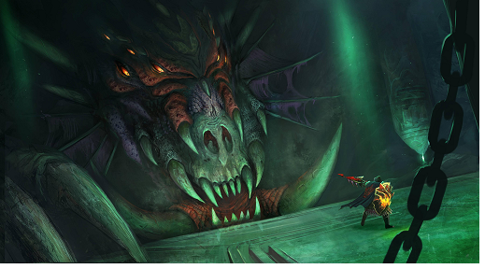

Intro

The queen black dragon is the 2nd strongest monster in all of Runescape. It can only be fought alone so it is recommended to be prepared with the best equipment you can get if you are planning to challenge it.

Requirements

Required -- 60 summoning

Recommended – Defense 70+

Range/Mage 90+

Prayer 43+

Summoning 67+

Herblore 85+

Hitpoints 85+

Quests

None are required however [Song from the Depths](http://runescape.wikia.com/wiki/Song_from_the_Depths) is highly recommended to reduce damage

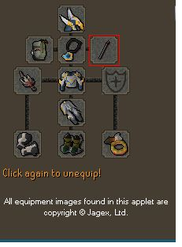Gear Profile’s

High Cost Gear (Range)

Helm – Armadyl Helmet

Cape – Ava’s Device

Necklace – Saradomin’s Murmur

Bolts – Royal Bolts

Wep – Royal Crossbow

Chest – Armadyl Chestplate

Legs- Armadyl Chainskirt

Gloves – Royal Spiky Vambraces

Boots - Glaiven Boots

Ring – Archers’ ring

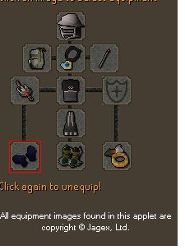

Void Gear (Range)

Helm – Void Ranger Helm

Cape – Ava’s Device

Necklace – Saradomin’s Murmur

Bolts – Royal Bolts

Wep – Royal Crossbow

Chest – Void Knight Top

Legs – Void Knight Robes

Gloves – Void Knight Gloves

Boots – Glaiven Boots

Ring - Archers’ Ring

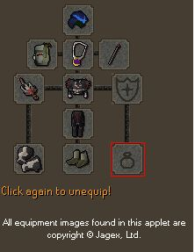

Welfare (Range)

Helm – Saradomin Coif

Cape – Ava’s Device

Necklace – Amulet of Glory

Bolts – Royal Bolts

Wep – Royal Crossbow

Chest – Royal D’hide Body

Legs- Royal D’hide Chaps

Gloves – Royal Spiky Vambraces

Boots – Snakeskin Boots

Ring – Wealth/Life

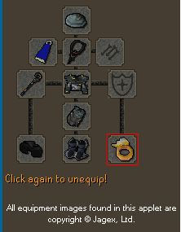

Mage

Helm – Ganodermic Visor

Cape – God Cape

Necklace – Saradomin’s Hiss

Bolts – N/A

Wep – Polypore Staff

Chest – Ganodermic Poncho

Legs- Ganodermic Leggings

Gloves Ganodermic gloves

Boots – Ragefire Boots

Ring – Seers’ Ring

No other mage setup is recommended unless it is swapping out necklace, boots, ring, or maybe Void.

Highly recommended NOT to however if you feel the need to not have super antifire potions then for range use chaotic/rune crossbow with antifire shield. Mage is not supported as of right now without polypore staff. Once again this is NOT recommended as kills will take a long time and food eaten will be substantially more.

GUI setup

Recommended setup – FOOD – Rocktail/Shark

Summoning – Highest possible BoB. If maxed . Steel Titan(untested as of 1/18/13

Tactics – Mage/Range most useable.

Quick Pray – Protect mage/Soul Split and highest . boosting Range/mage prayer available.

# of Pray pots – 5 should suffice for almost any setup . (Adjust as you see fit while running script)

Potion 1 – Best Mage/Range pot available or overload

Potion 2 – Best defense pot available

Antifire – Super Antifire (unadvised to try without it)

Ability Bar Setup

Range –



Mage –

Other Requirements

Must have unlocked Port Sarim Lodestone

Bank

Your bank should have at least 20 available slots open for loot.

The following is what will most likely be needed in the span of 6 hours of running bot assuming no deaths. (summoning pouches is determined by which pouch you use)

240 Prayer potion (4)

48 super antifire potion (4)

48 Falador telly tabs

48 of any boosting pots you are using 4 dose only. (Ranging pot, Defense pot, etc.)

2K food.( this varies as each account uses different amounts of food per kill)

ONCE AGAIN THESE ARE THE MINIMUM I ADVISE TO ALWAYS HAVE MORE THEN THIS JUST IN CASE.

F.A.Q.

1 Q: Its isn’t looting my grave

A: Your grave ID hasn’t been added yet. Get the ID for Lily or use the best F2P one which cost 5k in Lumby church.

2 Q: It isn’t using my abilities

A: This can be causes by a few reasons. Most likely though check your chat area. If you see this “12423453124” simply hit enter. Otherwise check graphic settings and make sure action bar isn’t change so slot 1 is “1” not “q”

3 Q: It isn’t dodging firewalls

A: Currently they are not hooked by Powerbot. Lily is attempting ways around this but will most likely never be perfect. So deal with 1500 damage for now.

4 Q: It is not getting any kills always teleports away.

A: It teleports away because you are out of food. Unlike a human a program can’t judge and say well I can kill it in 3 more hits even though I’m out of food. A program says I’m out of food I must teleport.

5 Q: It gets stuck at bank trying to withdraw my pots but can’t because inventory is full of food.

A: The program deposits the BoB after every kill this sometimes happens because Runescape messed up that deposit BoB button and doesn’t work sometimes or it clicked on someone else’s Familiar.(Lily will be looking into ways around both)

6 Q: Script is not working I have another BoB pouch in bank though.

A: The script does not like using the last of an item in bank. Always keep more than needed in bank.

7 Q: It always is stuck at bank for me it gets a full inventory and while it is teleporting to Port Sarim it recalls my tortoise and rebanking and getting a full inventory again and repeating

A: No Fally tabs most likely (check all needed items in case)

8 Q: It always is stuck at bank for me it gets a full inventory and while it is teleporting to Port Sarim it recalls my tortoise and rebanking and getting a full inventory again and repeating

A: You have a custom teleport animation activated. Please remove it and try again.

Last updated 1/19/2013

v.06